GAC Website Review Final Report

**Prepared for ICANN’s Governmental Advisory Committee**

# Contents

[Recommendations 3](#_Toc407096063)

[Context and Scope of this Review 8](#_Toc407096064)

[GAC Website – Objective and Required Outcomes 10](#_Toc407096065)

[Current Website Arrangements 11](#_Toc407096066)

[GAC Website – Reported Strengths and Weaknesses 14](#_Toc407096067)

[Other Relevant Websites 20](#_Toc407096068)

[Conclusion 24](#_Toc407096069)

[Appendix A: Stakeholders 25](#_Toc407096070)

[Attachments: GAC Website Review Survey Results 26](#_Toc407096071)

# Recommendations

## Overview

* The existing GAC website uses an out-dated technology platform that is no longer adequately supported.
* Few GAC Members use the existing wiki functionality (that is, online collaboration and revision of work).
* The way the information is currently structured is not very useful – people find it difficult to find particular documents and information. The key source of documents is, instead, the GAC email list.

**RECOMMENDATION 1: That the GAC website be renewed and moved to a more appropriate technology platform. As the site is renewed, the structure and layout of the website should be reorganised so that specific information is much easier to find.**

## Budget and Resources

ICANN has allocated US$75,000 to the GAC website for the financial year 2014-2015. According to Chris Gift (Vice President, Online Community Services, ICANN) this funding can be used to pay for external web developers or can be allocated to GAC’s use of ICANN’s technical staff.

Given the experience of ICANN’s technical staff in reviewing and renewing websites for other SOs/ACs, it seems sensible to begin the renewal of the GAC website with their assistance and support. ICANN’s technical staff are aware of and have contributed to this review and are able to start work on renewing the GAC website in early 2015.

**RECOMMENDATION 2: That ACIG immediately begins working to renew the GAC website in accordance with this Report’s recommendations, with the ongoing support and assistance of the ICANN GAC Support team and ICANN’s technical staff.**

## Clear Objectives and Specifications

The existing GAC website was established without clear business or functional specifications. The key audiences for the website were not well defined. Nothing was provided in writing to the original developers.

In the table on page 6 of this report, ACIG has therefore prepared a set of outcomes and objectives for the GAC website which describes the key stakeholders. The survey results (particularly where questions focussed on who the GAC website should provide information for) validated and confirmed the desired outcomes, objectives and stakeholders.

**RECOMMENDATION 3: That the outcomes and objectives for the GAC website described on page 6 are adopted as the high-level strategic plan against which the GAC can, in the future, measure the progress and achievements of its website.**

## GAC Register of Advice

The GAC Register of Advice is, in some cases, missing key documents and information. The documents and information that *are* there are difficult to search. The GAC Register of Advice needs to be reviewed and improved in a separate, stand-alone exercise. ACIG plans to begin that review in early 2015. ACIG’s early view is that any improvements should draw upon the principles and approach of ISO 9001 quality standards, particularly as they apply to document controls.

It may also be useful to draft a set of internal guidelines for ensuring that all information is posted within the Register, and on the GAC website generally, in a consistent and widely understood way. This is particularly true in relation to the GAC Register of Advice.

**RECOMMENDATION 4: That ACIG begins a review of the GAC Register of Advice in early 2015, in consultation with the relevant ICANN staff.**

## Collaborative Workspace

The GAC does not currently use the functionality of the wiki to anything like its full potential.

With few exceptions GAC Working Groups often establish a separate email list and use it to communicate and share documents, rather than using the collaborative workspace of the GAC website. The GAC as a whole currently uses the GAC email list as the prime means of communication; however there is no archive of the mailing list currently available online.

Mr Ashwin Rangan, ICANN’s Chief Innovation and Information Officer, announced on 17 October 2014 a plan to develop for the SOs/ACs “a common stakeholder, community-wide set of tools and technologies.” (<https://www.icann.org/news/blog/working-together-to-tame-the-coming-tsunami>). He notes that:

*For example – The ALAC wants a set of Issues management Tools that, in its request, is almost identical to what the SSAC wants. The GAC and the ALAC are both requesting revised websites. The GNSO and ALAC are both seeking a Knowledge/Information Management tool. And so on…*

*To address this, we have a choice.*

*The Stakeholder communities could EITHER have different parts of ICANN be pressed to define, develop and deliver specific, point solutions to satisfy each of these requests, satisfying one Stakeholder community at a time.*

*OR, we can choose a path where a single Stakeholder community (or a small cross-community group) takes "ownership" of an idea, fleshes it out completely and, when almost fully-cooked, invites other Stakeholder groups to weigh-in.*

*The result could be a robust set of requirements that represents the collective needs of our vast, global community. We - the ICANN staff - can then take these requirements and source a tool or a set of technological capabilities in the most cost-effective and time-efficient manner. Of course, not everything will fit into this mind-map. However, there are many requests coming at us concurrently which* do *fit this model.*

Outgoing GAC Vice Chair Mr Tracy Hackshaw (Trinidad and Tobago) has volunteered to lead and co-ordinate GAC input into this project.

In adopting any new collaborative workspace or tool:

* The internal working methods of the GAC must shift from a reliance on email lists to an emphasis on using the online workspace. Such a shift will require leadership from a group of active GAC Members involved in working groups and with the skills and motivation to use the online workspace. However it seems possible that at least some members might continue to avoid using the online workspace.
* All GAC Members must have access to appropriate information and training that will enable them to use the workspace effectively.

**RECOMMENDATION 5: The GAC continues to use wiki functionality until the existing website is renewed and/or until alternative online tools (and training) are made available by ICANN.**

## Site Navigation

The work and the priorities of the GAC have changed over time but the GAC website has not necessarily changed accordingly.

The ICANN support team has, in the past, had limited time and resources available to devote to maintaining and updating the content of the website. The recent appointment of the ACIG GAC Secretariat and additional support staff is beginning to ease this situation. Changes to the website including additional content (Fact Sheets) and better links between pages are already occurring. The ACIG GAC Secretariat and the ICANN support team have been improving the existing website incrementally: adding useful and relevant content as well as adjusting the navigational structure where and as required.

Development of the new website’s structure, and of the best means of sourcing particular information and documents, will be an ongoing and iterative process. Outgoing GAC Vice Chair Mr Tracy Hackshaw (Trinidad and Tobago) has volunteered to lead and co-ordinate GAC input into this project. He will be supported by ACIG, ICANN GAC Support staff and ICANN’s technical staff.

Ideally people accessing the site will be able to find their way to the required information from more than one direction through the appropriate use (for example) of internal links, cross-references and side menus.

A preliminary site structure is provided to begin the discussion (see following page).

Some of the information will be publicly available, some will be accessible to ‘Members Only’. We will liaise with ICANN technical staff to find out how best to structure that split.

HOME

* Keep the information here clear and simple.
* Perhaps an introductory video from the Chair
* Announcements
* Contact information (gacsec@icann.org)
* Appropriate menu and search options
* Links to ICANN home and to other SOs/ACs

ABOUT

* All the information that is currently in the various fact sheets we've prepared this year:  ‘About the GAC’, ‘About the leadership team’, ‘about the supporting teams’, etc.
* GAC Operating Principles
* Links to Membership information, Meetings, Communiqué archive, etc

GAC WORK

* Structured as per the work streams document.
* Subsequent pages (child pages) for each topic and links to relevant ICANN and other SOs/ACs’ topic pages; and/or
* Child pages for working groups (or links to joint working group sub-sites).
* GAC one-pagers on PDP developments.
* GAC communiqué archive
* Other archival information (from past GAC work efforts)

ADVICE REGISTER

* Register of Advice

MEMBERSHIP

* This information might instead be included under ‘About’ but, given that it is one of the most-visited pages, having a separate tab might be useful.
* List GAC Representatives (with photos of each)
* List GAC Observers
* Fact Sheets (How to join the GAC / change GAC representative)

MEETINGS

* List of past meetings (with agendas, communiques, briefings, minutes, transcripts)
* Next meeting
* Calendar
* Fact Sheets (how to use Adobe Connect; attending your first GAC Meeting)

CORRESPONDENCE

* Separate tab, or include under GAC Work.

FAQs

* A set of Frequently Asked Questions (FAQs) is currently in preparation. This page could also provide useful contact details and cross-references to other pages within the new GAC website.

**RECOMMENDATION 6: That a consultative and iterative approach be used in the development of the new website’s structure, led by Mr Tracey Hackshaw.**

## Content

The content on the current GAC website is updated as required by the ICANN GAC Support staff (usually by Julia Charvolen). This assists the GAC to maintain its independence and reduces delays that may result from having to ask ICANN technical support personnel to perform the updates. It also ensures that the person doing the updates is deeply familiar with the website and can make links and adjustments as appropriate and necessary.

Where possible and appropriate, content should be available on the site in html format as well as via pdf documents (to ensure easy access from a variety of devices).

A review needs to be undertaken of the existing archival information available on the website to identify (and, where possible, rectify) any information or document gaps.

**RECOMMENDATION 7: All existing GAC online content is to be transferred to new website. ICANN GAC Support staff should continue to be responsible for updating the renewed website, and will review existing archival material for gaps and omissions.**

## Other Important Considerations

It is appropriate for a collective “governmental” website such as the GAC’s to demonstrate best practice in the use of website design, programming and implementation.

**RECOMMENDATION 8: Any new website must comply with the IPv6 specification (including being fully backward-compatible with the IPv4 specification).**

To the extent possible, information on the renewed GAC website should be provided in the six UN languages plus Portuguese. Currently some pdf documents are available in translation (all of the Fact Sheets, for example) but not the html information on the web page. This situation looks set to continue into the near future.

**RECOMMENDATION 9: ACIG will continue to liaise with ICANN technical staff about best practice options for providing information in multiple languages.**

The GAC website is, and will continue to be, accessed by people using a wide variety of devices and via a range of bandwidths (some will have very slow access, for example).

**RECOMMENDATION 10: Any new website must be able to be used on a wide variety of devices and via a range of bandwidths.**

It is appropriate for governments to demonstrate best practice in ensuring the GAC website is accessible to people with disabilities.

**RECOMMENDATION 11: Any new website must comply with relevant accessibility guidelines to facilitate easy access for people with disabilities.**

# Context and Scope of this Review

The purpose of this review of the GAC website is to provide the GAC with:

* information about the current GAC website; and
* recommendations for improving the GAC website.

This document has been prepared for ICANN’s Governmental Advisory Committee (GAC) by the ACIG GAC Secretariat. ACIG is an independent consulting firm engaged to provide secretariat support to ICANN’s GAC. As part of its contractual obligations, ACIG must

*“Provide a briefing paper outlining recommendations and best practices to make use of the GAC website as a collaborative and functional tool for: a) GAC Members b) ICANN community c) other key stakeholders d) general public.”*

*ACIG/ICANN Contractor Consulting Agreement, 2 June 2014*

According to the agreed approach (outlined below) preparing the briefing paper outlined in the contract was to be a two stage process. This document is the culmination of Stages 1 and 2.

A list of the stakeholders engaged while preparing this report is provided at Appendix A.

## Approach

ACIG approached the GAC website review in two stages:

* Measure the performance of the existing GAC website against the site’s agreed objectives.
* Identify specific and practical improvements that will enable more efficient and effective delivery of services and information.

The evaluation criteria that ACIG used to conduct the review were:

* Relevance – What is the GAC website needed for? What is it trying to achieve?
* Effectiveness – Does the website produce the intended outcomes in the best way possible?
* Efficiency – Does the website produce the outputs and intended outcomes in an efficient manner that represents value for money?
* Future Directions – What are the opportunities for improvement, and over what timeframe?

#### Stage 1 - Measure the performance of the existing GAC website against objectives

The key activities in this stage were to:

* Articulate the GAC website objectives;
* Prepare the evaluation framework and key evaluation questions;
* Collect and analyse quantitative data (eg site usage statistics, budget information);
* Liaise with key stakeholders (eg ICANN CIO & IT Support, GAC Support Team members);
* Assess the quality of the information and identify any gaps; and
* Review all information for evidence of achievement against intended outcomes, and identify any unintended outcomes.

At the end of **Stage 1** ACIG presented the GAC with a description of the existing GAC website including an overview of the website history and background, the current arrangements (including technical and funding issues), and other issues for consideration. Th Stage 1 document was sent to the GAC email list on 25 September 2014, subsequently posted on the GAC website, and included as an agenda paper for GAC’s meeting at ICANN51 in Los Angeles.

The key information from that Stage 1 document is included in this document.

#### Stage 2 - Identify specific and practical improvements that will enable more efficient and effective delivery of services and information

The key activity during this stage was ACIG’s consultation with stakeholders including, most importantly, GAC members and observers and non-GAC users and potential users of the website.

ACIG sought this information through:

* an online survey sent to all GAC members and observers;
* an online survey of non-GAC users of the website; and
* consultation with ICANN community members.

ACIG also sought input about how best to improve the GAC website from ICANN CIIO & Technical Support staff, from ICANN’s GAC Support staff, and from other relevant stakeholders.

As well, ACIG worked with ICANN’s GAC Support staff to review the existing websites of ICANN’s other Advisory Committees and Supporting Organisations in an effort to determine what works best (and what does not).

# GAC Website – Objective and Required Outcomes

|  |  |  |  |  |
| --- | --- | --- | --- | --- |
| **GAC Website Objective**   * An information rich resource that is easy for a variety of stakeholders to navigate and that functions as a collaborative tool for GAC members.     **Context**  Anecdotal evidence strongly suggests that the GAC website originally created in 2011 is now difficult to use and does not adequately meet the needs of stakeholders. | **Activities**   * Determine agreed objectives for the GAC website * Measure performance of the existing GAC website against the site’s agreed objectives. * Identify specific and practical improvements that will enable more effective and efficient delivery of services and information. * Implement any recommended improvements within an agreed budget. * Measure performance of the new GAC website against the site’s agreed objectives. * Implement ongoing cycle of review and improvement. | **Outputs**   * A relevant, effective and efficient website that meets the needs of a range of stakeholders:   + Existing GAC Members   + New and potential GAC Members   + GAC Leadership Team   + ICANN staff   + ICANN community members (including other supporting organisations and advisory committees)   + General public * Clear and concise information about:   + the GAC   + how the GAC operates   + what the GAC is currently working on * Easy to navigate archival information, including the GAC Register of Advice. * Effective online tools and workspace for GAC Members and GAC Working Groups. | **Short- & Medium-term Outcomes**   * Increased ability of new and potential GAC members to learn about the GAC, and how it operates. * Increased ability of ICANN, the ICANN community and other key stakeholders to learn about the GAC, how it operates, and what the GAC is currently working on. * GAC members increasingly use the GAC website as a collaborative tool. * Increased use of the website by all stakeholders. | **Long-term Outcomes**   * Enhance the ability of GAC to provide public policy advice to the ICANN Board. * Improved relationships between the GAC and other members of the ICANN community. * Better understanding of the GAC by ICANN, the ICANN community and other key stakeholders. |

# Current Website Arrangements

The GAC website can be viewed at: <https://gacweb.icann.org/display/gacweb/Governmental+Advisory+Committee>

The GAC website is a wiki. The site uses a stock Confluence installation with a custom theme. In general terms, a **wiki** is a type of web page that allows anyone with an Internet connection to create and modify pages easily and quickly. Wikipedia is a well-known example.

GAC Members and Observers are routinely provided with access to the Members Only section of the GAC website. Anyone with such access can edit the site: adding and deleting documents; or deleting, adding or changing information already there. In practice few, if any, members use this functionality. Nearly all updates and changes to the website are made by the ICANN GAC Support Team (and specifically by Julia Charvolen or, formerly, Jeannie Ellers).

## History and Background

For several years the GAC website was managed and hosted by various versions of the GAC Secretariat. Changes to the secretariat arrangements led to changes to the website.

A website working group was established within the GAC. This group proposed criteria for the new website and revised the final product before its release.

The existing website was set up from scratch in 2011 and finished in August of that year. Sourcing information from earlier iterations of the GAC website proved difficult and as a result there are some gaps in the GAC archive.

The ICANN technical staff members who created the GAC website no longer work for ICANN but current IT staff members provided an informed opinion about the original software choices:

*I think they chose a wiki because we had recently migrated our community and staff wikis from Socialtext to Confluence, which is very easy for people to use. It provided a way for our staff to easily manage site content without having to rely on the web team to do so, while also allowing GAC members to do the same.*

GAC support staff confirmed that in 2011 it was important to the GAC that it be able to update its own website, without having to rely on the ICANN web administration staff. Confluence was already in use as a collaboration tool for ICANN as well as for other Supporting Organisations and Advisory Committees.

At the time, the GAC was also adamant about its immediate requirement for a collaborative working space in order to work through the issues surrounding Early Warnings and new gTLDs.

*I built the Early Warning system based on the wiki so that it would function how [the GAC] wanted it to.*

Using a wiki also minimised costs.

*The site does not cost [ICANN] anything financially. We have a free community license from Atlassian and any other site plugin vendors as we are a not-for-profit organization.*

*The wiki platform was available and a good way to make sure the GAC could do their work on schedule without having to wait for ICANN’s project [and budget] planning processes.*

## Administration of the GAC Website

ICANN’s IT personnel spend “hardly any” time working on the GAC website.

*It’s administered by GAC Coordination staff. They will typically come to me if they have a problem or need a custom solution for a goal they are trying to achieve, but I do not administer it.*

The GAC’s support personnel (previously Jeannie Ellers and now Julia Charvolen) estimate that they average an hour per day administering and updating the GAC website.

*One problem is that as I tried to use it to assist with research etc I’d find things that were wrong or formatted weirdly and go down the rabbit hole of trying to fix it. Upkeep [was a problem] because it was a constant struggle to get [the GAC website] organised. Because I didn’t find the platform to be intuitive it was the source of a lot of frustrations.*

The work of updating the website tends to peak immediately before and after each ICANN meeting, when support staff spend far more than hour each day working on the site.

Specific projects also add to the administrative workload. For example the original ATRT review prompted an addition to the website of the GAC Register of Advice. Creating the register involved “*a lot of handicraft by GAC Support Staff to graft all the parsed pieces onto the website*.”

## Site Traffic

GAC website traffic was not recorded until the ACIG GAC Secretariat asked for some statistics, in early August 2014. The figures recorded since then show:

* Average page views per day: 2289
* Minimum daily page views: 1292
* Maximum daily page views: 3554

During August 2014 the twenty most popular pages were:

* Home page – 10327
* Early Warnings received from GAC Member(s) after the EW Deadline – 644
* GAC Early Warnings – 311
* GAC Representatives – 307
* 2013-09-09-wine and vin – 271
* About the GAC – 161
* GAC Operating Principles – 160
* GAC Register of Advice – 144
* GAC Members – 141
* GAC Observers – 99
* Elected Officers – 96
* GAC Recent Meetings – 96
* GAC Announcement Archive – 95
* GAC Intersessional Meetings – 83
* GAC Meetings Archive – 77
* 2013-04-11-Safeguards-Categories-2 – 70
* GAC Advice Tracking – 69
* Resources – 68
* ICM Registry Application – 68
* ICANN Bylaws – 57

## Site Content

The existing GAC website provides a great deal of content in html and pdf formats. As an archival resource, however, it has a number of shortcomings:

* There is no search function
* There are gaps in the archives – some documents are missing, others (such as the minutes of early GAC meetings) were never created.
* The available information is in no way indexed, nor are documents saved and filed according to an agreed taxonomy (that is, an agreed file naming protocol).
* The website has no strategic plan or guidelines to determine what information it should provide or link to.

In summary, the GAC website is an information-rich resource that is not well organised.

# GAC Website – Reported Strengths and Weaknesses

## Overview of Survey Results

Two related themes emerged strongly from the surveys of GAC website users:

* The way the information is currently structured is not very useful – people find it difficult to find particular documents. The key source of documents is, instead, the GAC email list.
* Information should be organised by topic, and each topic should include all the relevant background documents, briefings, and archival information.

To follow is a discussion of the survey results which summaries the other main findings. The full results of the two surveys are attached in separate pdf documents (refer to page 6).

## Summary Discussion of Survey Results

In October 2014 ACIG surveyed the GAC and, in a separate survey, other users of the GAC website. All who completed the surveys remained anonymous.

We received a total of 52 responses:

* 30 responses from GAC Members (and/or observers); and
* 22 responses from other users of the GAC website.

This was a solid response rate, high enough to ensure that we can draw valid conclusions from the data. The responses from each group surveyed were similar.

#### C:\Users\michelle\AppData\Local\Temp\Chart_Q1_141218.pngHow often do you visit the GAC website?

*Results from Survey of GAC Members*

A third of GAC Members use the website “a few times a week.” Most (43%) use it “a few times a month” and a large minority (17%) use it “less than a few times a month.”

Similar usage patterns were reported by other users of the GAC website.

**Implications:** The GAC website is accessed on an ‘as required’ basis. It is not a site people use to idly browse – instead people access it to find a particular piece of information or document. Daily updates, posts or alerts do not seem necessary at this stage.

#### Navigation and finding information

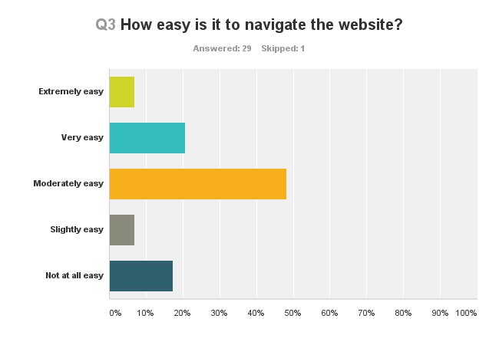

*Results from Survey of GAC Members*

It seems likely that those who used the website more often found it easier to navigate. But many respondents reported that it was sometimes difficult to find the information they were looking for.

Sometimes the necessary documents were not there:

*I typically have to resort to emailing requests for specific documents to the Secretariat*.

Some documents were on the website, but finding them was not easy:

*Taxonomy is not intuitive and the Member’s Area structure is not well organised*.

Some documents and/or information were not up to date:

*The information is scattered and the website is not always updated.*

**Implications:** The work of the GAC covers many topics, and has a history of over a dozen years. In order to reflect this, the GAC website must necessarily be rich in content and useful information. Relevant information must be current but the site must also provide an archive of background and historical documents.

Any revision of the GAC website must, as a priority, make navigating the site – and sourcing a necessary document – as easy as possible.

#### How useful is the information on the GAC website?

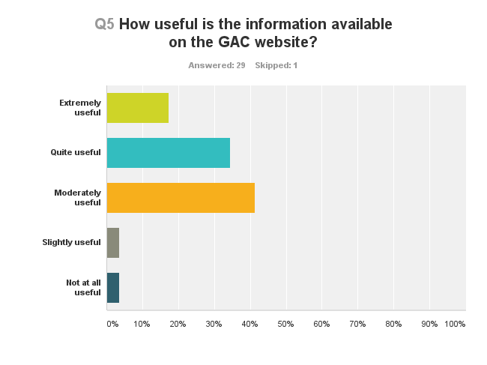 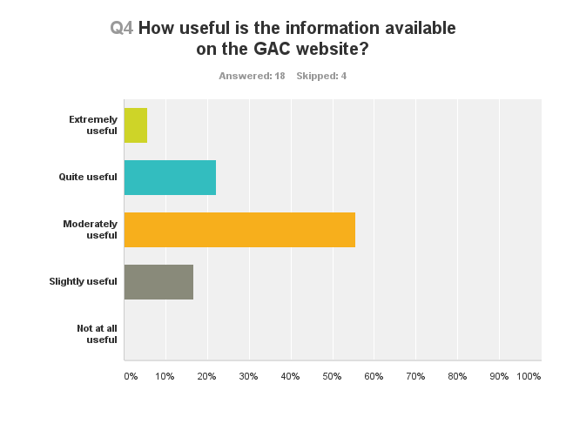

*Left: Results from Survey of GAC Members Right: results from Survey of other users of GAC website*

The majority of GAC members, and the majority of other GAC website users, found the information that *was* available on the website moderately or quite useful.

In particular both groups of users commented on the generic ‘About GAC’ information on the publicly available part of the website.

*The “About the GAC” folder is a good presentation of the GAC...The “GAC Meetings” section is all right too. Past meetings and their documents are orderly laid out and are easy to indentify. It is also useful embedding meeting documents in the agenda. The factsheet about GAC leadership is also good.*

A number of users of the site who were not GAC members sometimes wanted information that is not possible to provide:

*[I want to know] who takes what policy position and why.*

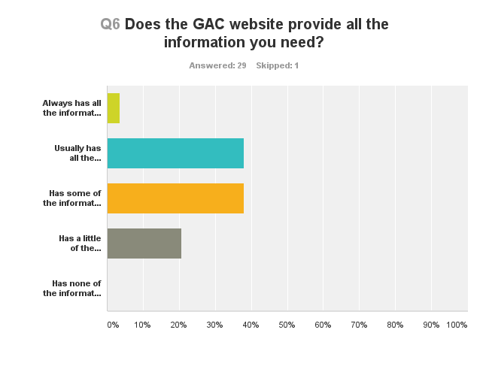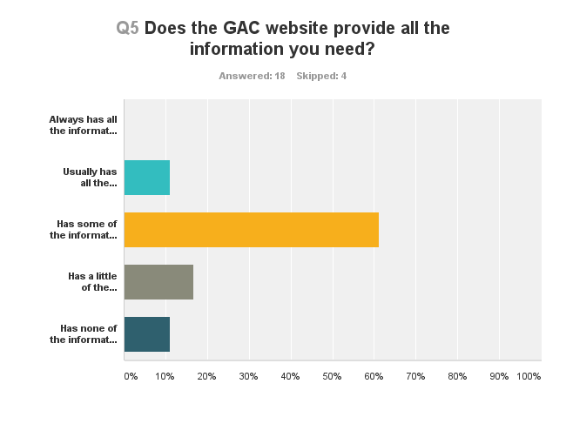

*Left: Results from Survey of GAC Members Right: results from Survey of other users of GAC website*

Most GAC Members felt that the GAC website “Usually has all the information I need” (38%) or “Has some of the information I need” (38%).

However a sizeable minority of GAC Members responded that the GAC website “Has little of the information I need” (21%).

*Usually use the GAC website as a reference area since most of the discussions still take place on the mailing list.*

The majority of other users responded that the website “Has some of the information I need” (61%).

**Implications:**  The GAC website already provides much valuable content. The issue is finding it – particularly when the information relates to a particular topic that the GAC is working on. When users can’t find the information they need, the GAC website may need to provide an alternative source of information. This might include contact details for the relevant working group, for example, or for the GAC Secretariat and Support Staff.

#### Wiki: Using the GAC website as an interactive tool

The GAC website is a wiki. In general terms, a **wiki** is a type of web page that allows anyone with an Internet connection to create and modify pages easily and quickly. Wikipedia is a well-known example.

For the GAC website, any GAC Member with access to the Members Only section of the GAC website can edit the site: adding and deleting documents; or deleting, adding or changing information already there.

Only a quarter of GAC Members (24%) have ever used the GAC website as an online interactive tool or workspace. Of those, at least some had used the interactive areas devoted to working groups only to access information and did not themselves upload any material.

Many GAC Members were unaware of the wiki functionality. Some that did know found it difficult to use, or to find information about how to use it.

*The use of the GAC site as a wiki is not well known or explained, and it should not be considered a “tool” until such time as all or a majority of GAC members use it as such. If the GAC is to accept the wiki functionality of the site, there needs to be much more information provided as to how to use the wiki function to conduct the GAC’s work intersessionally.*

**Implications:** GAC Members should consider whether they actually need the GAC website to also be a collaborative workspace, or whether it should be only an information source.

Other, separate online tools may well become available for the use of all SOs and ACs via the project recently initiated by ICANN’s CIIO. This issue is discussed more fully in the Recommendations section of this document, on page 4.

#### Visual appeal

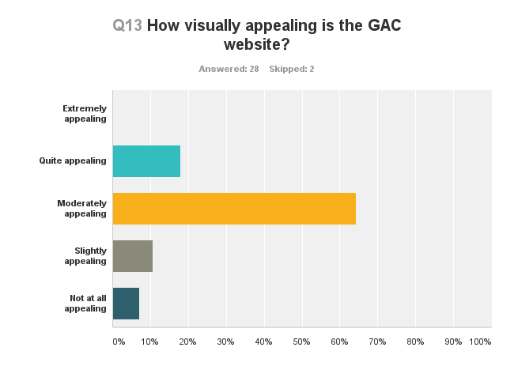 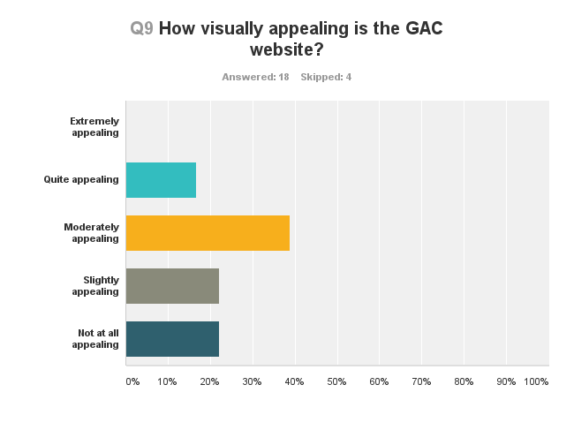

*Left: Results from Survey of GAC Members Right: results from Survey of other users of GAC website*

The majority of all survey respondents felt that the current GAC website was moderately appealing to look at. And the majority of all survey respondents also responded that visual appeal was important to them.

**Implications:** The look and feel of the GAC website needs some improvement in order to meet the users’ expectations.

#### Overall Satisfaction

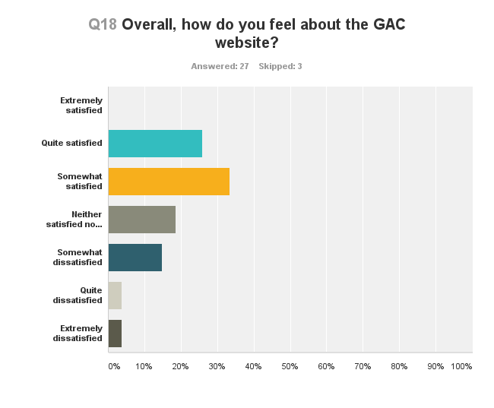 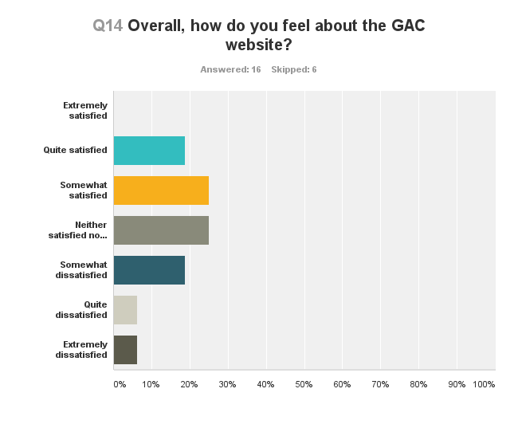

*Left: Results from Survey of GAC Members Right: results from Survey of other users of GAC website*

The majority of GAC Members are at least “somewhat satisfied” with the GAC website. Other website users are slightly less satisfied with the site.

This, and the data already discussed, confirms the anecdotal evidence that originally led to this review: that the GAC website can be difficult to use and does not adequately meet the needs of stakeholders. But, for all that, the website is not awful. Most users find it useful, at least some (or even most) of the time. ICANN Support staff have, in the past and currently, done a good job of compiling useful information in an information-rich and complex environment.

## Overview of ICANN IT and Support Staff Comments

The following comments about the GAC website were provided during ACIG’s consultations with ICANN IT and support staff.

Reported strengths:

* *“User-friendly, ability to collaborate, feature-rich, nice appearance.”*
* *“Useful as a collaborative tool, with spaces for [collaboration] dedicated to each Working Group for example [but] it hasn’t been used much as such.”*
* *“The wiki is a good document management system if used properly.”*

Reported weaknesses:

* *“It’s not actually a website and has a hard time functioning as one.”*
* *“[The GAC website is] not particularly appealing and welcoming.”*
* *“The graphics don’t work well, there are only specified styles and templates you can use to do page design, and it’s not very pretty to look at.”*
* *“Custom-theme makes some customization options difficult or not possible; custom-theme has been buggy.”*
* *“Links have an unwieldy structure (some are unpresentable as other than hyperlinks) and also break for no apparent reason. [This lack of] permanence is not really ideal for a repository.”*
* *“The current structure of the website is far from intuitive when looking for information – and some [information] is stored on multiple pages, without links.”*
* *“Not user friendly. You have to go through too many steps to access one page [in order to update it]. Each time you go onto another page you have to re-enter your credentials even if you are logged in already.”*
* *“There is no SEARCH function.”*

# Other Relevant Websites

ICANN has its own website, of course, as does each of ICANN’s Supporting Organisations and Advisory Committees (SOs/ACs).

ICANN’s website has recently been revamped and at least some of the SO/AC websites are likely to be revised or renewed in the near future.

For the purposes of comparison and learning, ACIG worked with the ICANN GAC Support team to produce the following overview, which includes the websites of: ICANN, ALAC, GNSO, ccNSO, ASO and NRO. Our special thanks to Julia Charvolen for researching and compiling this information.

## Key Lessons

The ICANN SO/AC websites (including the GAC website) are structured in similar ways:

* Homepage – with the latest announcements from its own community.
* About – What the SO/AC is.
* Resources – helpful documents for the community.
* Meetings / activities – Calendaring of meetings

Some websites have an additional icon leading to social media sites and some communities post daily information. This is not currently a priority for the GAC website.

After reviewing the different community websites, it seems that the GAC website is not the worst! Like other community websites, the GAC website covers the main topics of interest and has resources available for GAC members.

However the way information is displayed does not make the GAC website easy to use for GAC members or newcomers. The core information *is* available but has to become easier to find. In this regard, the ccNSO and ASO websites may be useful to consider. The former is interesting for the clear information provided and the latter, for the way it is structured.

To follow is on overview of the strengths and weaknesses of the other ICANN SO/AC websites.

## ICANN website

**https://www.icann.org**

|  |  |
| --- | --- |
| **Strengths** | **Weakness** |
| * Good overview of the website’s different features * Targets a full range of audiences * Search tool * Personal workspace available   + Account settings   + News settings   + Profile * Beginner’s guide * Regional engagement events – What is happening and where? * Glossary tool | * Structure somewhat unfriendly: Information should catch the eye – Main topics are not very easy to find on main page – Small banner top right * Sign-in tab – what for? |

On a general overview, the ICANN website is comprehensive. It targets a wide range of stakeholders from as newcomers through to longstanding members of the community. The ICANN website is a general portal where information can be found and shared, but it is not a tool enabling interactivity.

#### Relevance to the GAC Website

The GAC website must to have an outreach focus and as well as facilitating work within the GAC. In this regard, it may be helpful to study the ICANN website’s structure – in particular, how it reaches out to community members.

## ALAC website

**http://atlarge.icann.org**

|  |  |
| --- | --- |
| **Strengths** | **Weaknesses** |
| * Correspondence page * Contacts page * Translation tool – Translates most of the website * ‘Join’ icon | * Not user-friendly * Outdated content (ex. Community outreach events) * Google custom search – Searches in general, still not easy to source info * Too much information, not well structured, too much for one page   + Standing WG   + Ad hoc WGs   + Archived WGs * Website leading to a wiki page – Too confusing. Why not structured only on website? * ALAC = 5 regions, where are they on the website? One tab/ region? |

#### Relevance to the GAC Website

Currently, ALAC is renewing its website. Their main focus is to have a community website that is user friendly and welcoming. The current ALAC website is not well-structured. Big blocks of information are provided in a small font, which is not helpful. As well, it is difficult the information is presented in a way that makes it difficult for a newcomer to discern what might be strategically important (like the IANA transition) and what may be simple housekeeping information.

## GNSO website

**http://gnso.icann.org**

|  |  |
| --- | --- |
| **Strengths** | **Weaknesses** |
| * Translation tool for the website * Calendar view for the latest events/ conference calls * About page includes a short intro video * Once on a page, sub pages are listed on the side and visible : helps navigate on the website * Library tab: Classification of the document you are searching (transcripts, agenda item, announcement, presentation.) * Social media links | * The banner takes most the homepage: Some of the information is slightly outdated. * Staff have to ask ICANN’s web admin people to undertake every document posting |

#### Relevance to the GAC Website

In general, the GNSO website is comprehensive and contains the core information related to the GNSO stream of work. While the website could be structured differently from an aesthetic point of view, from an information perspective it is relatively user friendly and it is easy to source information. Unlike the GAC website, all information posted on the GNSO website has to be made via a request to ICANN’s web admin staff. This may lead to delays.

## ccNSO website

**http://ccnso.icann.org**

|  |  |
| --- | --- |
| **Strengths** | **Weaknesses** |
| * Main information is on the home page (topics, calendar, contact) * Resources page is clear and helpful – user-friendly * Guidelines for presenters – Tips to help presenters (topic of the presentation, performance, slides, handouts) – Community help <http://ccnso.icann.org/about/guidelines-presenters-ccnso-meetings-02may12-en.pdf> * Library tab: same as for GNSO * Quick Links tab highlighted: Community websites (ICANN, GNSO, GAC, SSAC, At-Large), FAQs, Bylaws, ccNSO guidelines, ccNSO Council meetings, etc) * Search tool * Welcome note from the ccNSO Chair : Outreach | * Operations page: inactive * A lot of information shared (but useful and comprehensive info) |

#### Relevance to the GAC Website

Although the ccNSO website is not aesthetically pleasing, it is comprehensive. Information is well displayed and to the point. The Quick Links page is particularly useful. The ccNSO Council Meetings page (<http://ccnso.icann.org/about/council/minutes.htm>) provides a useful example of how best to record face-to-face and teleconference meetings. It might be useful to consider this page if information about the Chair and Vice Chairs calls is to be posted on the GAC website.

## Address Supporting Organisation (ASO) website

**https://aso.icann.org/**

|  |  |
| --- | --- |
| **Strengths** | **Weaknesses** |
| * Different structure, more refined * Brief explanation of what ASO is about on the homepage. Helps users to see if this is community they want to get information about. * Election process page * Search tool * User friendly, easy to navigate * Sitemap – replaces the various banners that can be found on other SO/ACs websites | * No information/ links to other SO/ACs * ASO MoU translations should be linked to each page where the document is downloadable. * Lack of links on some pages. Each time a document is referred to, a link should lead to the document. * No translation of the website |

#### Relevance to the GAC Website

The ASO website is clear and navigation is fairly easy. Unlike other community websites, the ASO website is only structured around the ASO activities. However, the information is easy to find and goes straight to the point. For GAC purposes, it may be a good website to consider regarding how the information and the navigation is structured.

## Number Resource Organisation (NRO) website

**https://www.nro.net/**

|  |  |
| --- | --- |
| **Strengths** | **Weaknesses** |
| * About the NRO on the homepage, one short sentence, then click on read more tab * Structured same as the ASO website with member, region, start and end of term for each member – “NRO acts as the ASO”. * Brief list of what NRO mission is * Clear website, only way to navigate is through the tabs at the top of the website, no side banners – helps focus * FAQs (NRO , IPv4 and IPv6) * Quick Reference Points similar to Quick Links from ccNSO website (but no community outreach) | * No links to the SO/AC community websites but to regional members websites |

#### Relevance to the GAC Website

The NRO website offers a precise explanation of what it is and how it works. It is similar to the ASO website. Although a newcomer may understand what the NRO is, it is structured in a way that seems to target a professional audience.

# Conclusion

At the outset of the review process, ACIG determined to assess the GAC website against an agreed set of evaluation criteria (refer to page 6). Our findings are as follows:

* Relevance – *What is the GAC website needed for? What is it trying to achieve?*

To date the objectives of the GAC website have not been well articulated. But despite that, it has served the GAC as a fairly useful tool. Most GAC members can usually find what they are looking are for, and are moderately happy with the site. The challenge is in ensuring the GAC website can continue to be relevant to the GAC Member’s requirements in the face of the GAC’s increasingly complex and heavy workloads.

* Effectiveness – *Does the website produce the intended outcomes in the best way possible?*

The website is a moderately useful resource but it is not a model of best practice. Newcomers are likely to be able to find some useful information, but experienced GAC representatives are more likely to source relevant, current information from the GAC email list than from the website.

* Efficiency – *Does the website produce the outputs and intended outcomes in an efficient manner that represents value for money?*

The website is entirely funded and supported by ICANN. From the GAC’s point of view this represents excellent value for money but from ICANN’s point of view a more effective GAC website may allow support personnel to use their time more efficiently.

* Future Directions – What are the opportunities for improvement, and over what timeframe?

The GAC website is currently content rich: the problems lie in the way that content is organised. A renewed GAC website should draw upon the existing content while presenting it in a more effective and accessible way.

Given other SO/AC renewal activities within ICANN, and the ongoing development of online collaborative tools for the use of SOs/ACs, the timing is perfect for the renewal of the GAC website. With ICANN funding, work on the new website could begin in early 2015. Subsequent liaison with ICANN technical staff will likely include the preparation of a detailed project plan.

Detailed recommendations regarding the GAC website are provided at the beginning of this document, on pages 3-6.

# Appendix A: Stakeholders

In compiling the information provided in this document the ACIG GAC Secretariat engaged with the following individuals. To them all we extend our grateful thanks.

Allison, Steve Product Manager, Online Community Services, ICANN

Bengford, Laura Senior Product Manager, Online Community Services, ICANN

Charvolen, Julia GAC Services Coordinator, ICANN

Closson, David Director of IT Operations, ICANN

Ellers, Jeannie Currently: Global Stakeholder Engagement Support Manager, ICANN

Formerly: Manager GAC Coordination, ICANN

Gift, Chris Vice President, Online Community Services, ICANN

Nordling, Olof Director of Service Relations, ICANN

Perset, Karine GAC Relations Advisor, ICANN

Quinn, Reed Systems Engineer, ICANN

Rangan, Ashwin Chief Information and Innovation Officer, ICANN

Salvatierra, Marc Manager, Web Development, Online Community Services, ICANN

ACIG also conducted two online surveys: one of GAC Members, and the other of users of the GAC website. Our sincere thanks to all who took the time to complete the survey.

# Attachments: GAC Website Review Survey Results

Files in pdf format containing the full results of the surveys are available and accompany this report. The full results include charts and (anonymous) individual text responses.

If you do not have copies of the survey files but would like them, please contact:

* Ms Michelle Scott Tucker from the ACIG GAC Secretariat at michelle@acig.com.au.